Your company can enroll in Travel Incorporated's eDirect Hotel Direct Bill Solution. eDirect is one of the first automated direct hotel billing process that is **simple, secure and efficient**.

**How does it work?** The hotel nightly room rate and taxes for your entire stay will be directly billed to your company. The credit card used to hold your hotel reservation must be the card programmed in Travel Inc’s system. When this card is used, it will trigger our system to send the hotel a fax 72 hours prior to check in. The traveler will also get an email 72 hours prior to check in with a voucher authorization. *If another credit card is used as the guarantee for the hotel reservation, the traveler will be responsible for full payment upon check out.*

Travel Incorporated will submit a credit card authorization to the hotel through a secure data channel 72 hours prior to your check-in date.

Upon arrival at the hotel, the traveler should verify with the front desk representative that they have received the credit card authorization form. If they have not, the traveler may re-fax the credit card authorization directly from their eItinerary via their web-enabled mobile device. To re-fax, simply click on the icon as shown below. The fax process will only take a few minutes.

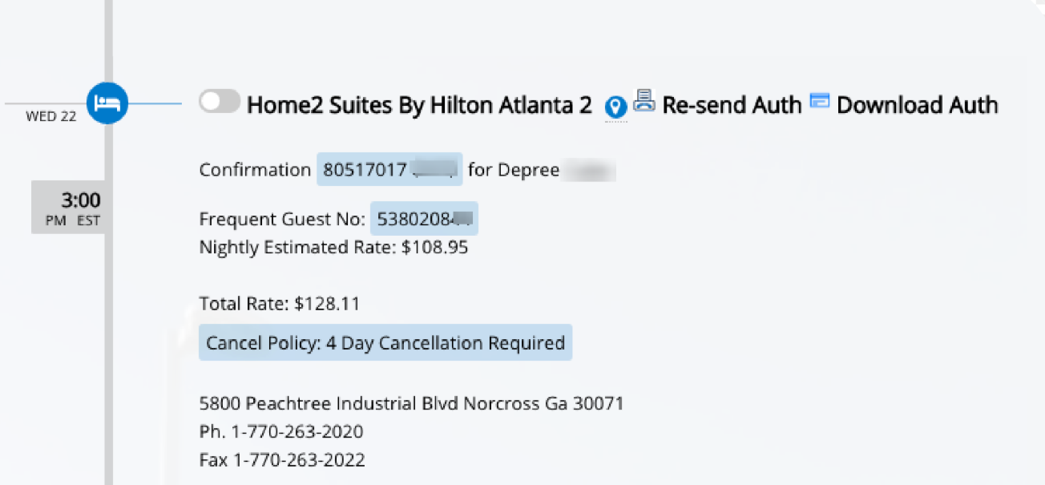

This icon will only be displayed on your eItinerary the date of arrival and not before. Once you click on the icon, a box will pop up to confirm you want the fax to be sent again to the hotel. Click on OK for the fax to be sent.

If the icon does not display, try refreshing your eItinerary by clicking the "Refresh Itinerary" link shown on the left side of your eItinerary. If the re-fax icon still does not appear after refreshing, or if the front desk representative provides you with a different fax number, please contact your Travel Inc agent for assistance.

