## AIRFARE COST COMPARISON EXPLANATION AND EXAMPLES

To ensure prudent use of travel funds, the University cannot pay or reimburse any additional costs resulting from traveler preferences. A **cost comparison** is **required at the time of booking** in the following circumstances:

* Indirect routing or extra stops for personal reasons.
* Travel prior to or after the required business travel dates.
* Using transportation methods that are not the most efficient or cost-effective (i.e. electing to drive/take a train versus fly when flying would be the most efficient and cost-effective option.)
* Departing from/returning to an alternate city (not near campus/headquarter city) for personal reasons.
* Any other situation where the traveler’s itinerary is modified for personal reasons.

Travelers must consider potential extra costs for transportation, lodging, meals, tolls, parking, etc.

Either the traveler’s *actual travel* or *comparison travel* -whichever is less expensive – is payable/reimbursable.

Acceptable cost comparisons:

* When booking via Concur, provide Concur screenshots per the guidance below. NOTE: If Concur isn’t returning results with a price, (usually international itineraries), a cost comparison MUST be obtained from the designated travel agency.
* When booking via the designated agency, request documentation such as emailed quotes.

Due to airfare pricing and availability fluctuation, accurate cost comparisons must be done **at the time of booking** to be valid. For screenshots it is recommended to “Save to PDF” or email the document the date the comparison was completed.

A valid Concur or agency cost comparison includes:

* + Proof that the cost comparison was done on the same date as the purchased actual airfare.
  + Proof that the travel dates shown on the comparison correspond with the UW business dates.

## Cost comparison examples.

EXAMPLE 1. Concur cost comparison for personal airfare is more expensive than the business airfare. EXAMPLE 2. Concur cost comparison for personal airfare is less expensive than the business airfare. EXAMPLE 3. Fox World Travel agent cost comparison.

# EXAMPLE 1. Concur cost comparison for personal airfare is more expensive than the business airfare.

Conference travel. The conference is September 17 – September 20 in New Orleans, LA. The traveler would like to spend a few extra days exploring New Orleans and combine the business trip with personal travel.

1. 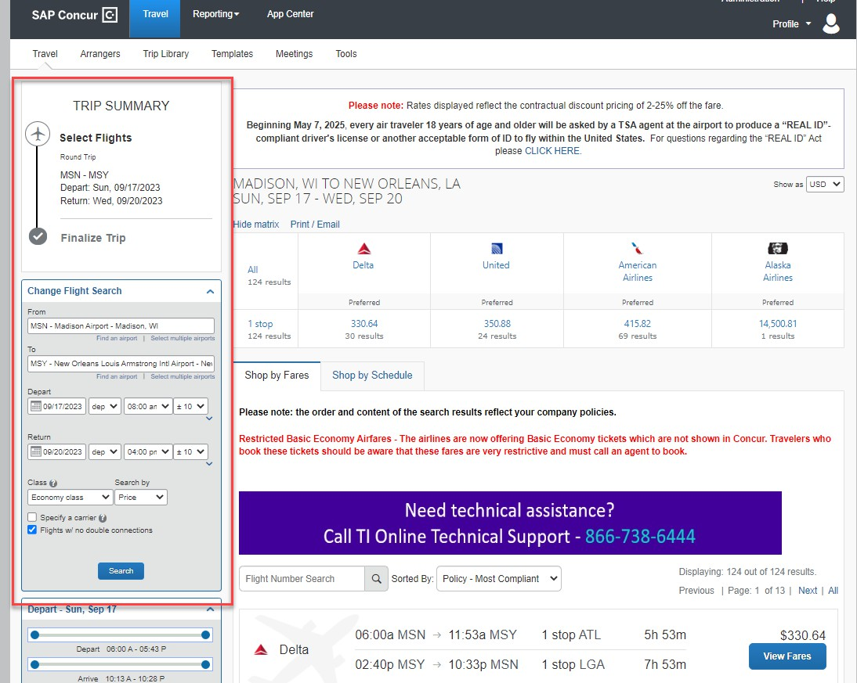Search Concur for approved conference dates.
2. 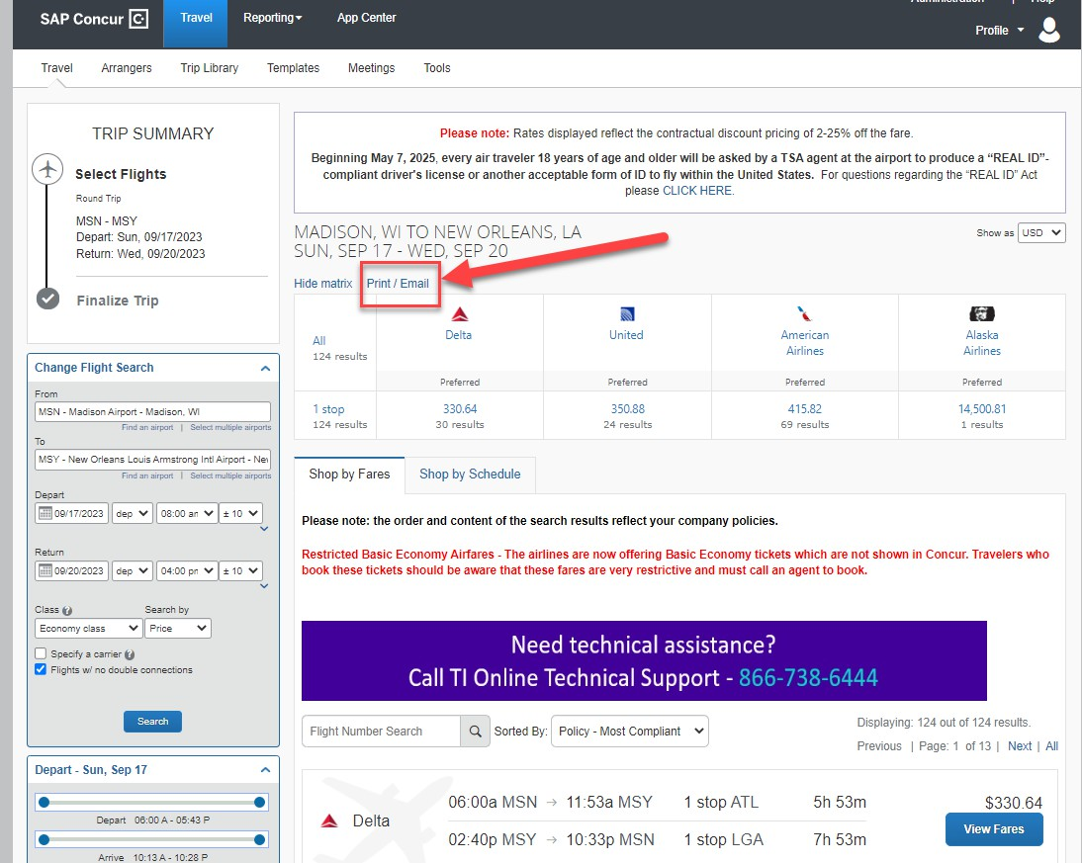Click “Print/Email”.
3. A new window will open with the search results. You may email the results to yourself or print the flights and “Print to PDF”.

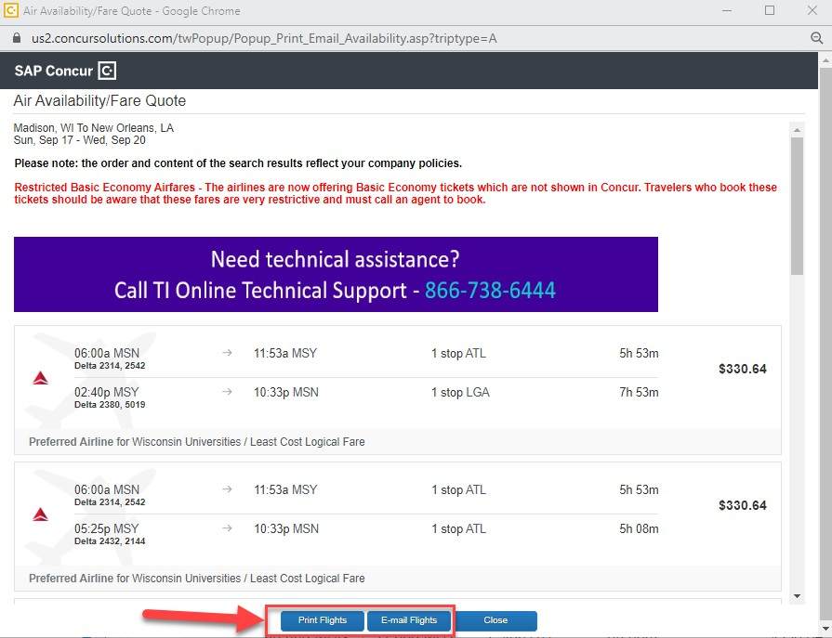

1. To “Print to PDF” click “Print Flights” and then:
   1. Select “Microsoft Print PDF”.
   2. Select “Print”.
   3. Note that the output document has the date and time the comparison was made.

*** Note – if you don’t see the date and time on your document, ensure under “more settings” you have checked “headers and footers”. ***

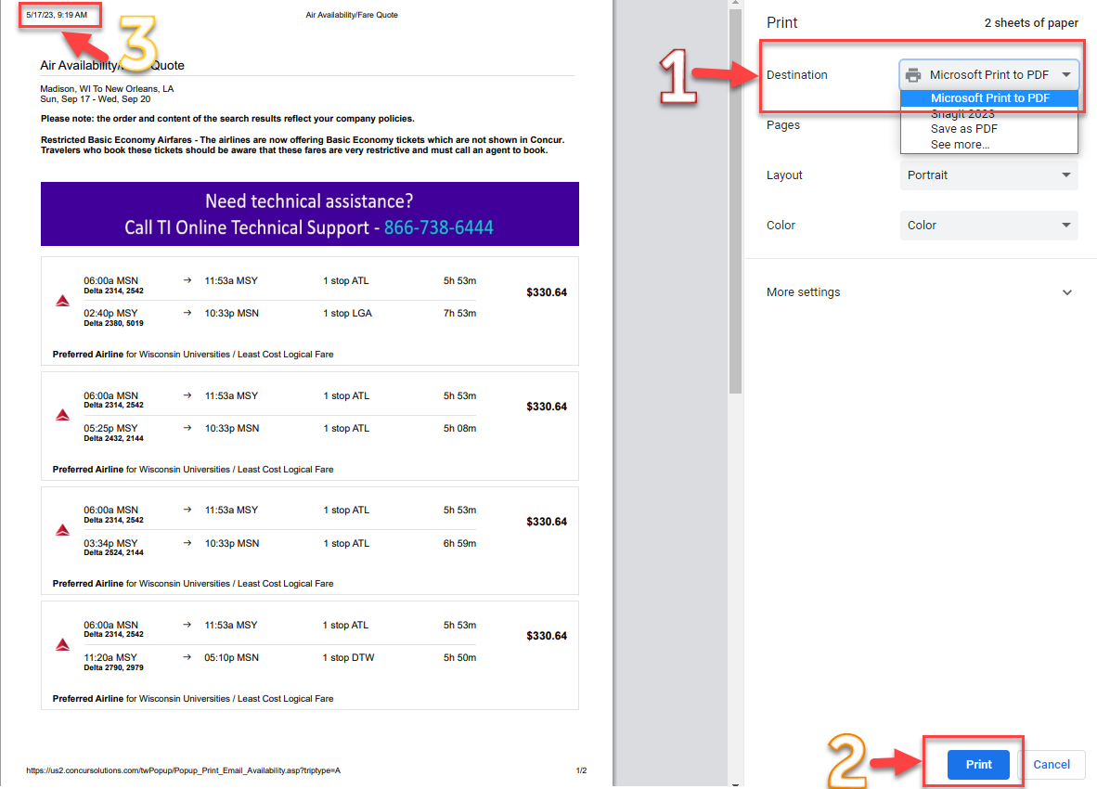

1. The airfare purchased for the personally preferred dates is $454.11 and the business portion cost is $330.64. Regardless of what the actual travel is, the maximum that will be reimbursed is

$330.64, the cost of the University related travel.

1. The cost comparison must be included with the documentation for the payment mechanism (e.g., expense report, purchasing card transaction).

# EXAMPLE 2. Concur cost comparison for personal airfare is less expensive than the business airfare.

University Event Travel. The event is an all-day event on October 21 in Las Vegas, Nevada. Business travel dates are October 20 – October 22. The traveler would like to visit family that lives in Las Vegas for a few extra days and travel October 20 – October 25.

1. 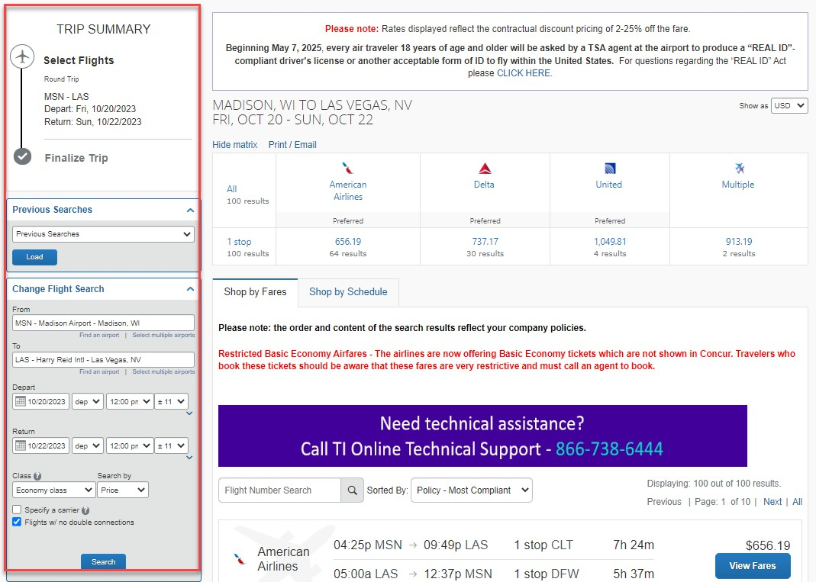Search Concur for approved conference dates.
2. 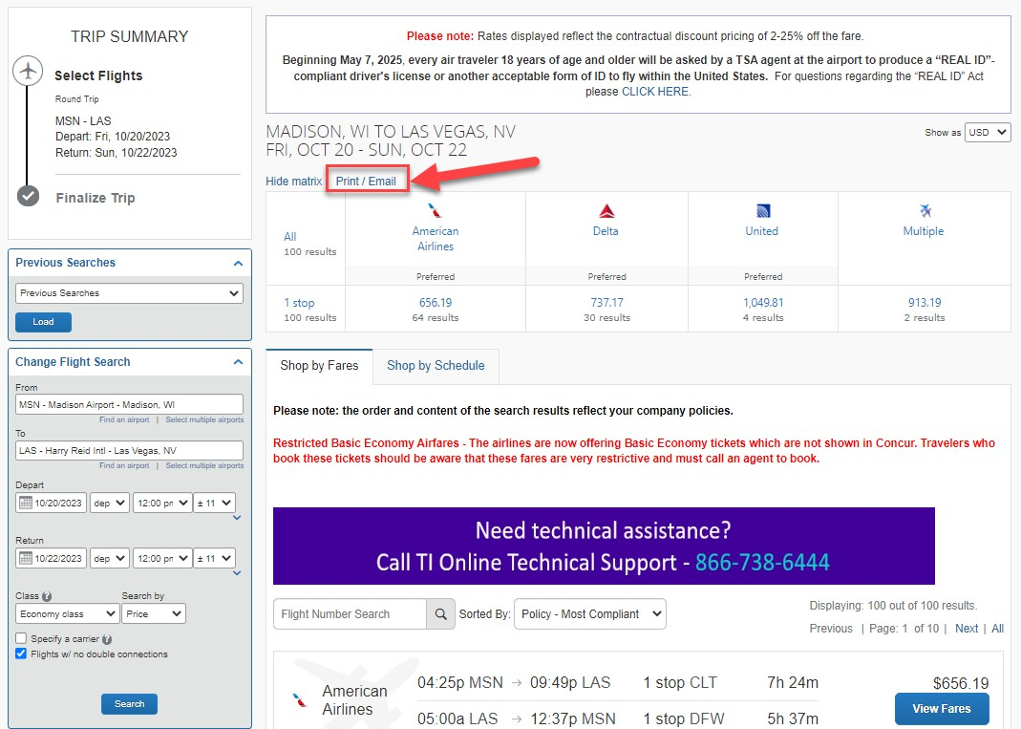Click “Print/Email”.
3. A new window will open with the search results. You may email the results to yourself or print the flights and “Print to PDF”.

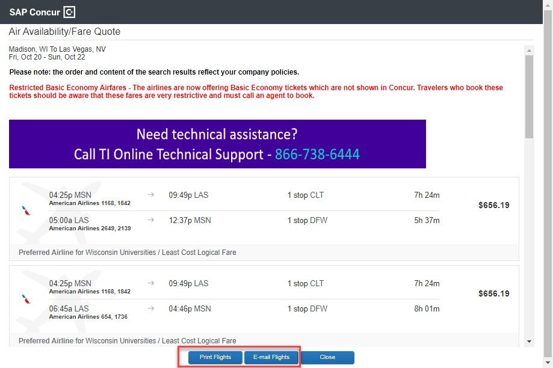

1. To “Print to PDF” click “Print Flights” and then:
   1. Select “Microsoft Print PDF”.
   2. Select “Print”.
   3. Note that the output document has the date and time the comparison was made.

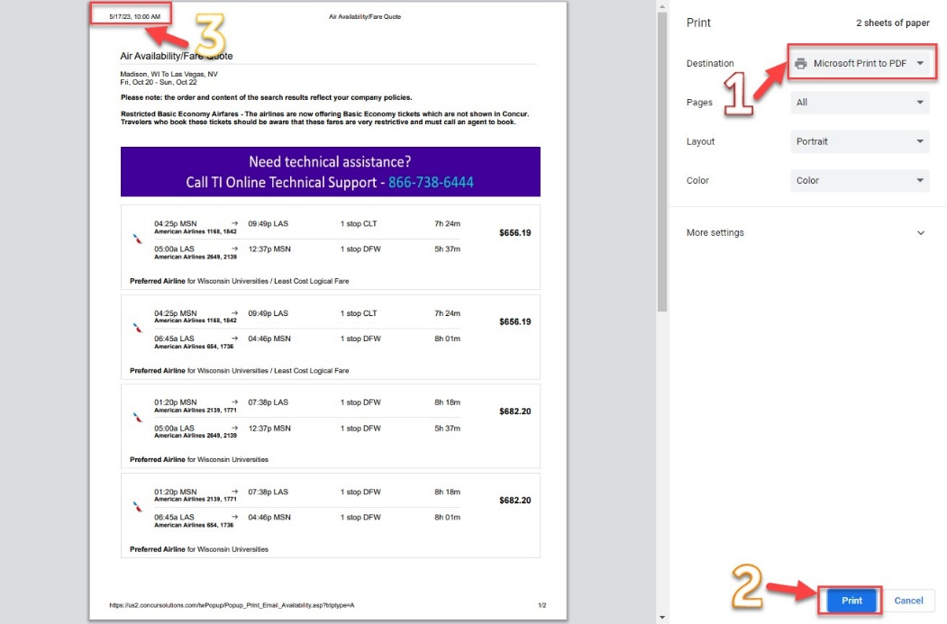

1. *** Note – if you don’t see the date and time on your document, ensure under “more settings” you have checked “headers and footers”. *** The airfare purchased for the personally preferred dates is $481.48 and the business portion cost is $656.19. The maximum that will be reimbursed is $481.48, only the cost of lowest option is reimbursable.
2. The cost comparison must be included with the documentation for the payment mechanism (e.g., expense report, purchasing card transaction)

# EXAMPLE 3. Fox World Travel Cost Comparison

1. Obtain cost comparison from a Fox World Travel agent for the business-related travel dates.
2. The entire cost comparison email, including the date the cost comparison was obtained, full business-only flight itinerary, and price, must be included with the documentation for the payment mechanism (e.g., expense report, purchasing card transaction).

Example of a Fox World Travel cost comparison.

NOTE that comparison MUST include date of comparison, full itinerary, and price.

