**Guidance for UW System Campuses Considering “Opening Travel”**

While each campus has the authority to independently determine when to travel, this guidance document is intended to inform decision makers on the current state of COVID (as of May 2021) and provide options for programming and/or restricting travel. We will send an additional update in August 2021.

**Current State on Travel - Domestic**

* More US companies and Universities are opening up travel domestically/continental US.
* Currently, COVID testing is not required for travel within the continental US, however masks are required for all public transportation through Sept 13, 2021
* UW System has posted many helpful COVID specific links on Travel WIse (including current restrictions by campus) <https://www.wisconsin.edu/travel/covid-19/>
  + Note that due to COVID, the UW System is no longer requesting carpooling, and each campus has the flexibility on how they would like to enforce use of fleet and renting versus use of own vehicle

**Current State on Travel - International**

* Many US companies and Universities are still restricting international travel to “essential only” or by documented exception type of approvals, with many not yet “opening up travel without restrictions”
* UW System Travel Wise site has added links and additional considerations for international travel <https://www.wisconsin.edu/travel/planning/international/>.
* Best practice is to have links to help educate students on risks (see UW Madison’s example) <https://studyabroad.wisc.edu/covid-19-faq/>
* UW System has changed our CISI Insurance in May of 2021 to include a $2,000 Travel Delay benefit – to help with any positive COVID tests before returning to US or while abroad
* Currently for entry/return to the U.S., travelers must provide evidence of a negative COVID-19 viral test taken within three calendar days of travel. Alternatively, travelers to the U.S. may provide documentation from a licensed health care provider of having recovered from COVID-19 in the 90 days preceding travel.

Current barriers to international travel:

* Many countries require negative COVID tests before entering, some also require additional tests upon arrival in country to avoid quarantine
* Some countries require quarantine at traveler’s personal cost, and penalties may include fines or arrest for non-compliance
* The allowance for entry to countries based on vaccination status and the use of so-called “vaccine passports” remain very much in flux; some countries may ultimately allow entry based on full vaccination certification, but this allowance may be restricted to vaccines approved within the destination country.
* Many countries now require medical insurance, or require a deposit (typically around $2,000 USD for two weeks meal/lodging expenses)
* Countries may restrict travel to and from other countries and change COVID-related entry requirements on short to no notice, as well as declare domestic social restrictions that may impact travelers’ purpose.
* COVID is still a major threat in many countries and vaccine distribution globally is not estimated to be complete until at least 2023 or beyond. Many countries remain at single digit percentages of their population vaccinated.
* The [US State Dept Travel Advisory Levels](https://travel.state.gov/content/travel/en/traveladvisories/traveladvisories.html/) for many countries are currently at “Do Not Travel” see below for the countries in red and the link to the current map
  + <https://travelmaps.state.gov/TSGMap/>

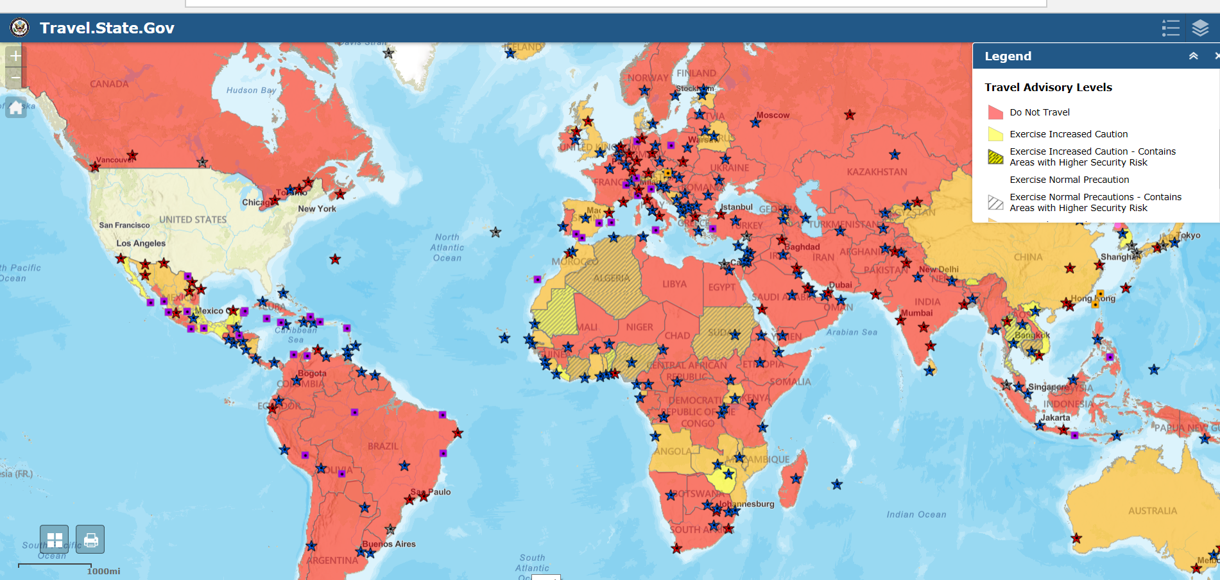

**Programming options for Travel** – please work with your [campus Travel Manager](https://www.wisconsin.edu/travel/support/) or contact Elizabeth Dressel [edressel@uwsa.edu](mailto:edressel@uwsa.edu) for options if you would like to do a phased opening of travel (options for domestic vs international approval configuration, as well as different rules for employees/guests/students)

**Additional helpful links**:

Harvard’s Travel Plan: <https://www.globalsupport.harvard.edu/news-events/coronavirus-advice-travelers>

Stanford’s Travel Plan: <https://healthalerts.stanford.edu/covid-19/travelers/>

University of Dayton’s Travel Guidelines and Plans: <https://udayton.edu/president/path-forward/return_to_campus/travel_guidelines_and_plans.php>

Articles regarding study abroad travel considerations during COVID:

<https://forumea.org/resources/guidelines/conducting-education-abroad-during-covid-19/>

<https://www.insidehighered.com/news/2020/11/19/study-abroad-looks-remain-limited-spring>